**Excel Export**

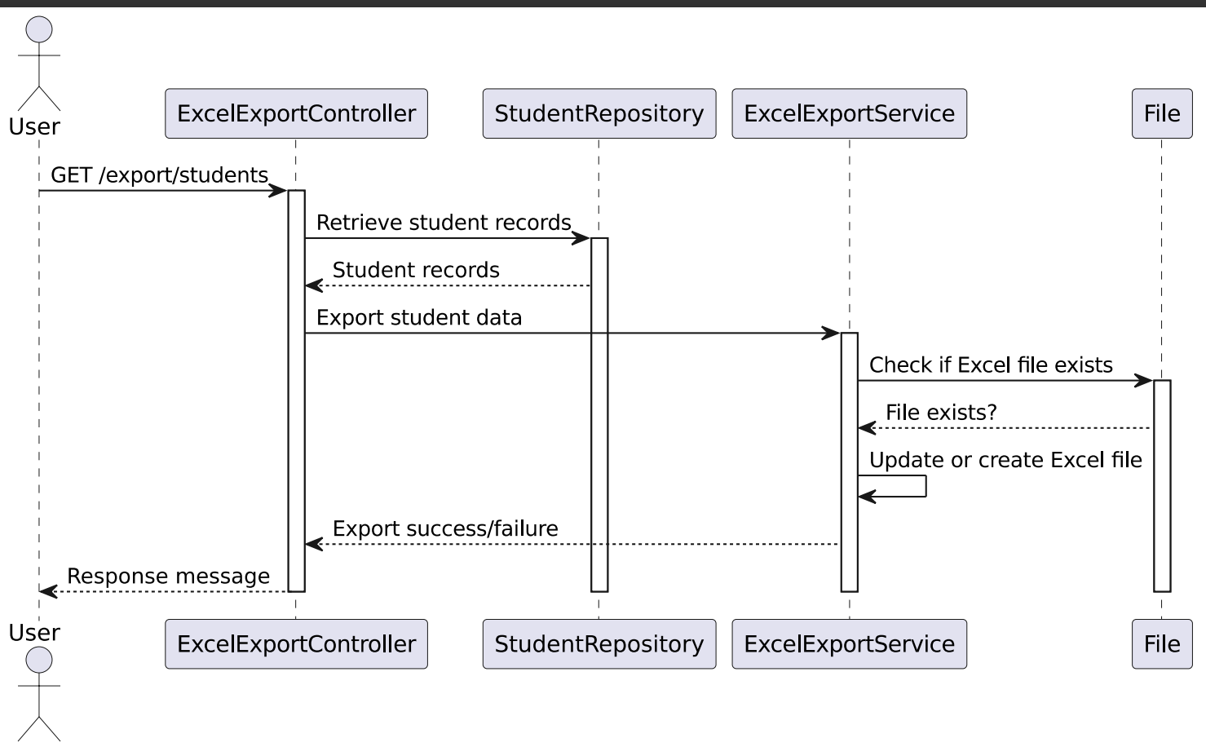

Class Diagram UserSeviceImpl: